# LabVIEW Function Generator Project

## 1. Introduction

This project involves the creation of a function generator using LabVIEW. The function generator is capable of generating various types of waveforms, adding noise to the signals, and implementing noise removal. The purpose of this project is to simulate real-world signal conditions and provide a platform to test noise reduction techniques.

## 2. System Design

The system is designed using LabVIEW's graphical programming environment. The major components include:

1. Waveform Generator: This module generates signals of various types, including sine, square, and triangle waveforms. Users can control the frequency and amplitude of the waveform.

2. Noise Addition Module: This module introduces noise to the waveform. The type and amplitude of the noise can be adjusted. The default noise type used is uniform white noise.

3. Noise Removal Module: A noise filtering mechanism is implemented to clean the noisy signal, restoring the original waveform. Noise in a signal refers to unwanted or random variations that interfere with the desired information. It can distort or obscure the signal, affecting its quality or accuracy.

**Types of Noise in Signals used:**

1. **Uniform White noise**
2. **Periodic Random noise**
3. **Gaussian noise**
4. **Gamma noise**
5. **Poisson noise**
6. **Binomial noise**
7. **Bernoulli noise**

**Key Characteristics:**

* **Amplitude**: Magnitude of the noise.
* **Frequency**: The spectrum over which noise exists.
* **Power**: Energy carried by the noise.

**Sources of Noise:**

* Environmental (e.g., electromagnetic interference)
* Hardware imperfections.
* Signal processing errors.

**Mitigation Techniques:**

* **Filtering**: Remove unwanted frequencies.
* **Shielding**: Protect equipment from interference.
* **Averaging**: Smooth out noise in repetitive signals.
* **Error Correction**: Detect and fix corrupted data.

### Block Diagram

Below is the block diagram of the implemented LabVIEW function generator system. It shows the process flow from waveform generation to noise addition and removal.

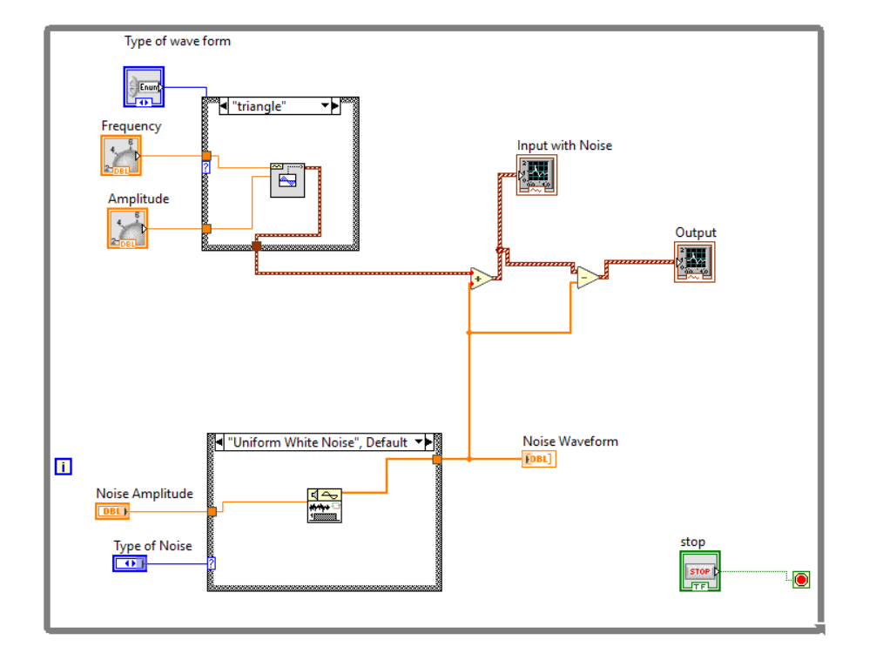

## Output

## 3. Methodology

The following steps outline the functionality of the LabVIEW program:

1. Waveform Selection: The user selects the desired waveform type (e.g., triangle) and specifies its frequency and amplitude.

2. Noise Addition: Noise is generated based on the selected noise type and amplitude and is added to the clean waveform.

3. Noise Removal: A filtering mechanism is applied to the noisy signal to remove the noise and retrieve the original waveform.

Each block in the diagram represents a specific function as detailed below:

- Waveform Generator: Generates the clean signal based on user inputs for frequency, amplitude, and waveform type.

- Noise Generator: Produces a noise waveform based on user-defined parameters such as amplitude and noise type.

- Signal Adder: Combines the generated waveform and noise to produce a noisy signal.

- Noise Removal Block: Implements filtering techniques to clean the noisy signal and restore the original waveform.

- Graphical Displays: Visualize the generated signals (clean, noisy, and filtered) for analysis.

## 4. Results

The system was tested for different waveform types and noise levels. The following observations were made:

1. The waveform generator successfully produced clean signals of various shapes and adjustable parameters.

2. Noise addition was accurate, and the noisy signals reflected the specified noise characteristics.

3. Noise removal effectively cleaned the signal, demonstrating the system's ability to restore the original waveform.

## 5. Applications

This function generator has applications in various domains, including:

1. Signal Processing: Testing and validating noise reduction algorithms.

2. Education: Demonstrating the impact of noise on signals and the effectiveness of filtering techniques.

3. **Embedded Systems**: Simulating real-world conditions for hardware testing.

## 6. Future Improvements

The system can be enhanced in the following ways:

1. Adding more noise types, such as Gaussian and periodic noise.

2. Implementing advanced noise filtering techniques like adaptive filters.

3. Enabling real-time signal visualization and analysis.